Test #1 Camera
The camera is the central data component of our blimp and it must be working properly to be able to transmit the pictures we take from the gondola. Before the pictures are transmitted we want the camera to function properly. The camera is capable of capturing images in different resolutions and different compression quality. Both of these must be working to ensure that images the blimp captures are adjustable and able to be set how we want.

Materials Needed for Test:
- Raspberry Pi Zero 2 W
- Raspberry Pi Camera Module 3
- Command Prompt / Pi Connect

Performing the Test:
- The first thing that must be done for the test is to connect to the pi, either by ssh or Pi Connect.
ssh blimp26@RASPBERRY_PI's_IP_ADDRESS
- Next ensure that you are in the correct directory with
cd /home/blimp26/0405
- There are 3 parameters for takepic.py. The first is resolution which can be set to 720, 1080, or 4k. The second is quality that can be set from 0-100 and control the compression of the image. Closer to 0 gets you a smaller file size but at the cost of image quality. And the reverse for closer to 100.
python3 takepic.py 720|1080|4k quality filename.jpg
- We will want to ensure that all levels of resolution work with a range of compressions
- First we can do.
python3 takepic.py 720 100 testcamera720_100.jpg
- Next do.
python3 takepic.py 720 50 testcamera720_50.jpg
- Lastly for 720p.
python3 takepic.py 720 25 testcamera720_25.jpg
- We will use SFTP as an easy way to transfer files from the pi to a separate computer for viewing as the pi is headless and must be accessed via SSH. First connect to pi from laptop using
sftp blimp26@RASPBERRY_PI's_IP_ADDRESS
- Using SFTP is like using linux commands, ls, cd, pwd, mkdir, rm, rmdir all work, using this navigate to the folder where picture were taken in this case
ls
cd 0405
- Then using SFTP from a computer we can transfer the image to a device that has a visual interface to inspect the images visually to see the difference in image quality while also inspecting the image size. Once you are in the directory of files you want then you just get and specify where you want to put the file on the computer and it transfers the file.
get [directory/file on pi] [local directory]
get testcamera720_25.jpg C:/user/Pictures
- Repeat step 10 for all images taken.
- Then repeat steps 5 through 11 for resolutions of 1080p and 4k. Those commands would be as follows for 1080p.
python3 takepic.py 1080 100 testcamera1080_100.jpg
python3 takepic.py 1080 60 testcamera1080_60.jpg
python3 takepic.py 1080 20 testcamera1080_20.jpg
get testcamera1080_100.jpg C:/user/Pictures
get testcamera1080_60.jpg C:/user/Pictures
get testcamera1080_20.jpg C:/user/Pictures
- And commands for 4k would be as follows.
python3 takepic.py 4k 100 testcamera4k_100.jpg
python3 takepic.py 4k 65 testcamera4k_65.jpg
python3 takepic.py 4k 30 testcamera4k_30.jpg
get testcamera4k_100.jpg C:/user/Pictures
get testcamera4k_65.jpg C:/user/Pictures
get testcamera4k_30.jpg C:/user/Pictures
- And quality can be used across all 3 resolutions. We are just trying to ensure that quality works across all 3 and compression works to compress images and give us a smaller file and then can see the difference in quality of different compression levels.
- End of Test.

Results:
Camera is able to be configured and a wide range of resolutions and quality are able to be produced, leading to a successful system that serves our needs for next block of the system.

Script: takepic.py
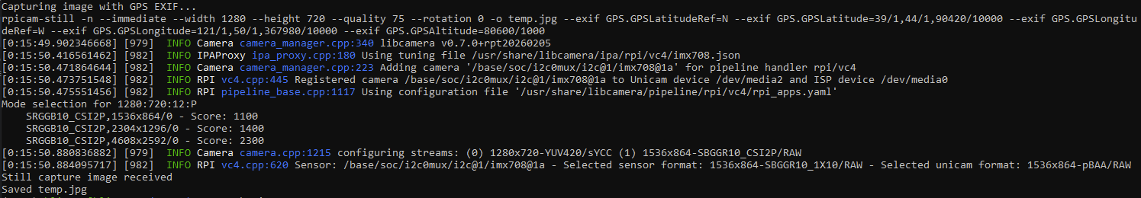

Test #2 Solar Pannel
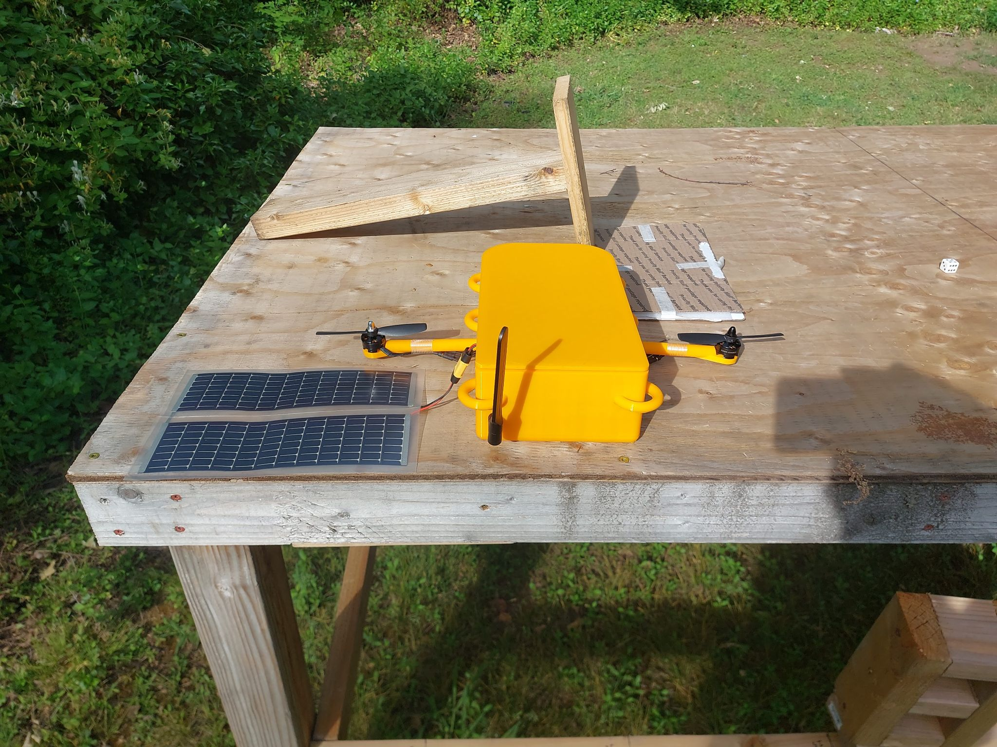
Materials Needed for Test:
- 2x of RC7.2-75 PSAF in Series
- CN3722 Solar MPPT Charger
- Multi Meter

Performing the Test:
- First ensure that solar panels in series are working and giving an output. V_{OC} = 11.1V and Operating voltage is 7.2v so depending on the sun levels ensure that the voltage is between 14.4V-22.2V. If covering the panel reduces voltage then the panel is operating correctly. The more sun the higher the voltage should be.
- Connect solar panel. If there is no output, counterclockwise adjust the MPPT pot until voltage appears.
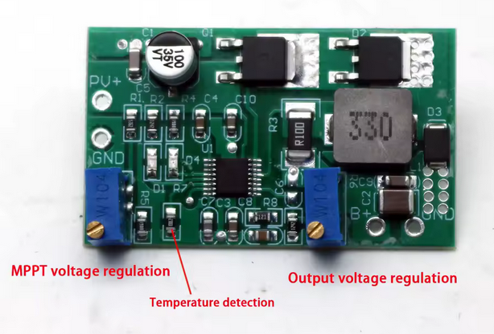
- Counterclockwise adjust output pot until LEDs blink, then set to the battery’s max voltage of 8.4V.
- Connect battery + ammeter. Fine-tune MPPT pot for max current (or match solar panel’s nominal voltage).
- Verify cutoff voltage with multimeter and adjust output pot if needed.
- End Test.

Results:
The MPPT board outputs 8.4V which will allow the battery to be trickle charged to extend the duration of the gondola’s operation.

Test #3 Motors
The brushless motors and esc that control them are how the blimp navigates. They must be functioning correctly in order for the blimp to maneuver.

Materials Needed for Test:
- Raspberry Pi Zero 2 W
- 2x of FEICHAO 2204 2300KV Brushless Motor
- 2x of EPower 20A 2S ESC
- PCA9685 I2C PWM board
- Command Prompt / Pi Connect

- The first thing that must be done for the test is to connect to the pi, either by ssh or Pi Connect.
- Next ensure that you are in the correct directory with
cd /home/blimp26/blimp_venv
- Next activate the virtual python environment if not already active
source venv/bin/activate
- The pwm board allows control of many pwm outputs using i2c
- The test script allows to test the motors
  - Set motors to MINIMUM to arm the ESCs
If not, entering program mode is possible
if that is the case, do not change throttle level and disconnect ESCs
  - After the 12 123 beep chime you can test freely
Script: python programesc.py
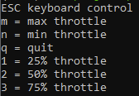
- End Test.

Results:
The motors' full range of rpms are accessible and working as intended. This allows us to control the blimp as we desire and at more specific throttle levels than this test if we choose to.

Test #4 Servo Motors
The servos control the orientation of the motors

Materials Needed for Test:
- Raspberry Pi Zero 2 W
- 2x of MG90D 270° Servo Motors
- PCA9685 I2C PWM board
- Command Prompt / Pi Connect

- The first thing that must be done for the test is to connect to the pi, either by ssh or Pi Connect.
- Next ensure that you are in the correct directory with
cd /home/blimp26/blimp_venv
- Next activate the virtual python environment if not already active
source venv/bin/activate
- The test script allows to test the servos
  - The ESCs need to be plugged in as they provide power to the servos
Script: python servoctrl.py
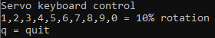
- End of test

Results
The servo motors can move the arms adequately and have good precision. They can be set to any point in 270 degrees of rotation.

Test #5 LTE
Cellular LTE is the main connection of the blimp while it is operating. It is how we will control the blimp and send commands to set settings and run programs. It is also how we upload data from the blimp, each image and then the metadata which include our gps location when the picture was taken.

Materials Needed for Test:
- Raspberry Pi Zero 2 W
- SIM7600G-H 4G HAT (B)
- Command Prompt / Pi Connect

- The first thing that must be done for the test is to connect to the pi, either by ssh or Pi Connect.
- The modem manager and network manager automatically detect the lte board and configure the network interface.
- If needed it can be done manually with the following commands and qmi command line interface
  - sudo systemctl disable ModemManager
  - sudo qmicli -d /dev/cdc-wdm0 --wds-start-network="apn=simbase,ip-type=4" --client-no-release-cid
  - sudo qmicli -d /dev/cdc-wdm0 --wds-get-current-settings --client-no-release-cid --client-cid=[cid]
  - sudo ip link set dev wwan0 up
  - sudo ip a add [addr] dev wwan0 metric 700
  - sudo ip route add default via [gate] dev wwan0 metric 700
- Check the modemmanager assigned an ip correctly
Command: ip address
- Check the status of the connection
Command: mmcli -m 0
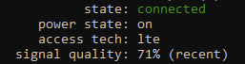
- Test the connection by pinging using the lte network interface
ping -I wwan0 -c 1 8.8.8.8
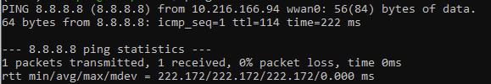
- End of test

Results
Modem manager is correctly set up to automatically configure the lte/wwan0 network interface, and transmission speed and latency are acceptable.

Test #6 Gps
The gps is used to get the global position of the blimp, as well as altitude from sea level. It is critical for autonomous flight.

Materials Needed for Test:
- Raspberry Pi Zero 2 W
- PA1616S GPS
- Command Prompt / Pi Connect

- The first thing that must be done for the test is to connect to the pi, either by ssh or Pi Connect.
- Next ensure that you are in the correct directory with
cd /home/blimp26/blimp_venv
- Next activate the virtual python environment if not already active
source venv/bin/activate
- The test script outputs the coordinates and altitude
Script: python gpstest.py

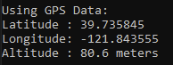
Taking the coordinates to google maps shows position accurately to a 5 meters. The system is in the backyard.
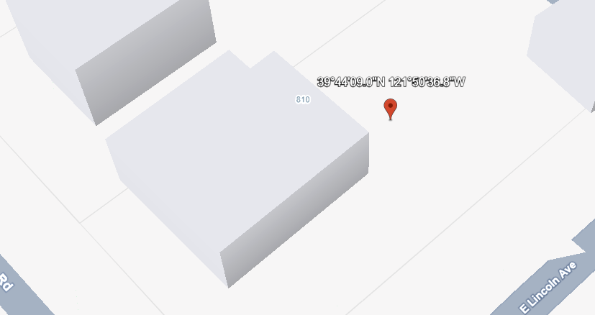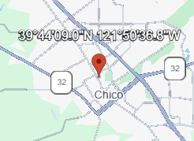
- End of test

Results
The gps module is very accurate and important for the navigation of the blimp.

Test #7 9 Axis Attitude Sensor
The gyroscope is used to monitor the position, heading, and acceleration of the blimp. It uses a 3-axis accelerometer, 3-axis gyroscope, and 3-axis magnetometer. The most important part is the euler angle which gives the direction the blimp is facing with respect to magnetic north. When combined with the gps the blimp knows where it is, and how it's moving.

Materials Needed for Test:
- Raspberry Pi Zero 2 W
- BNO055 Absolute Orientation Sensor
- Command Prompt / Pi Connect

- The first thing that must be done for the test is to connect to the pi, either by ssh or Pi Connect.
- Next ensure that you are in the correct directory with
cd /home/blimp26/blimp_venv
- Next activate the virtual python environment if not already active
source venv/bin/activate
- The test script outputs all the data the bno055 collects
Script: python bno055test.py
The board needs to be moved around briefly for it to calibrate.
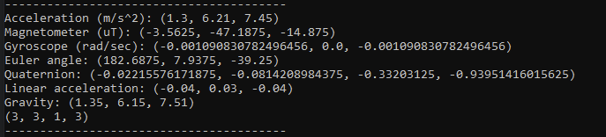
The first number of euler angle, which is the surface plane angle relative to north, is accurate to a couple of degrees.
- End of test

Results
The bno055 is very accurate and important for the navigation of the blimp.

Test #8 Cloud upload

Materials Needed for Test:
- Raspberry Pi Zero 2 W
- Command Prompt / Pi Connect

- The first thing that must be done for the test is to connect to the pi, either by ssh or Pi Connect.
- Next ensure that you are in the a directory with a file
- The rclone command is used to upload files to the google cloud folder. The -v tag is to show a verbose output of the command.

Command: rclone copy [file name] blimp26:/BlimpImages -v
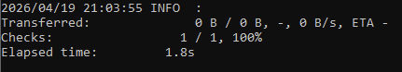
The file correctly appears in the cloud folder
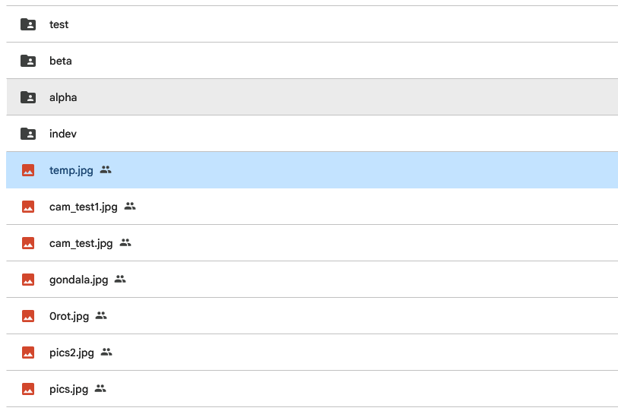
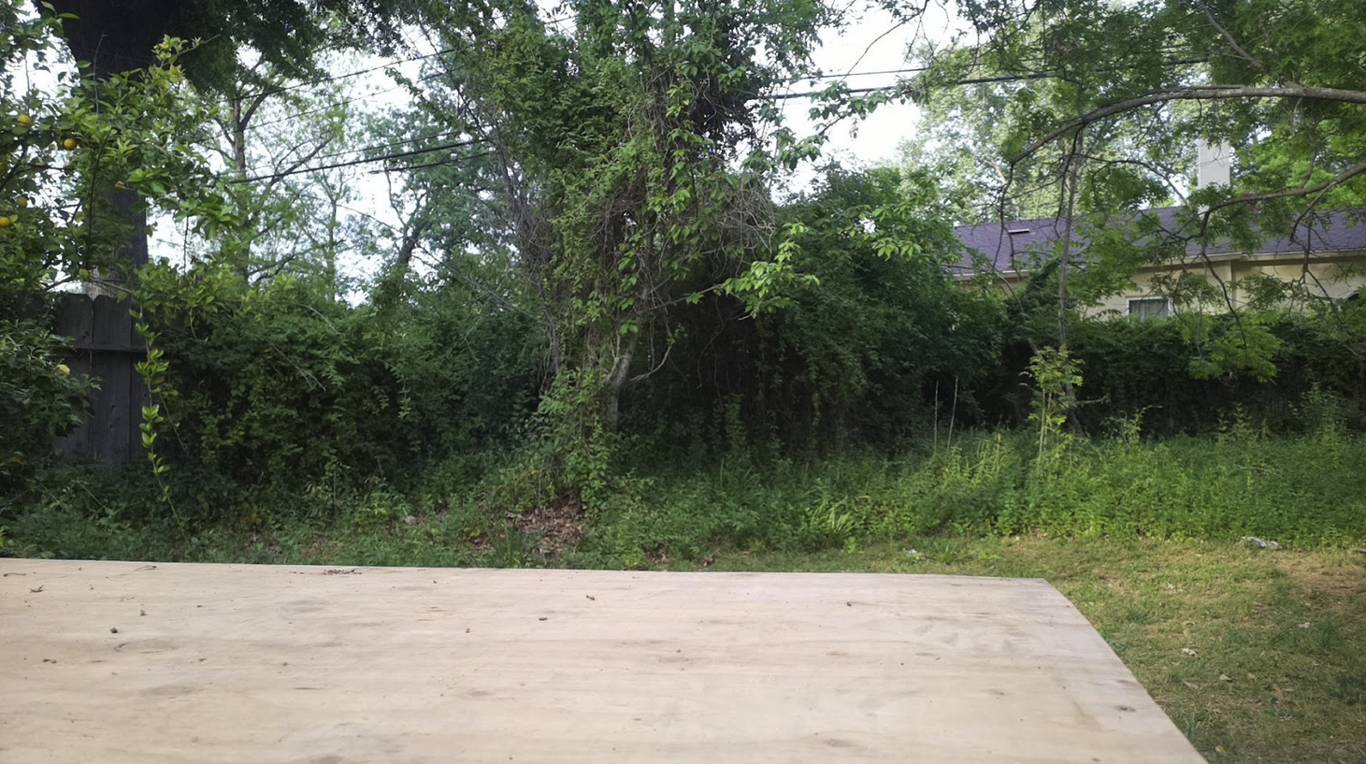

- End of test

Results
The file is transferred accurately over lte to the cloud folder.

